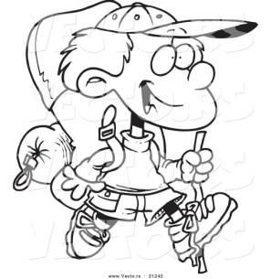
Vinci Park

Science Camp Fundraiser

Come join us and show this flyer on
Wednesday, October 15th between 11am - 9pm
1706 Oakland Rd #10, San Jose, CA 95131
Vinci Park receives 50% of the proceeds
to help pay for science camp.
(Tell your families, friends, neighbors, co-workers, etc.)

Vinci Park

Science Camp Fundraiser

Come join us and show this flyer on
Wednesday, October 15th between 11am - 9pm
1706 Oakland Rd #10, San Jose, CA 95131
Vinci Park receives 50% of the proceeds
to help pay for science camp.
(Tell your families, friends, neighbors, co-workers, etc.)

